Proposal for
PlayStation 3 Distributed Shared Immersive Visualization Environment
Detection of Water Droplet Erosion

Sponsored By
IBM

Version 1.4
September, 19 2007

Prepared by
Syed Ali
Paul Ireifej
Justin Law
Carlos Lazo
Nicholas Matthews
Shahab Rastegar
Thomas Smith
Mahmutcan Tarzi

Executive Summary

The purpose of a steam turbine is to produce the maximum amount of electrical energy in the minimum amount of space. Steam is first heated in a boiler, where it reaches temperatures of approximately 1000ºF. It enters the turbine at a speed greater than 1,000 mph. A double-flow turbine design has steam entering in the middle and then traveling in both directions toward the ends of the section.
General Electric (GE), currently the largest manufacturer of steam turbines, is having issues with the erosion of their turbine blades within 2 – 3 years of use. The water droplets in the steam flow make contact with the turbine blades and the turbine captures the energy from the steam. However, the water droplets erode the blades over time. Due to this erosion, the energy that is captured decreases over time. As time increases, the blade tips are damaged and the turbine is damaged. The erosion is often concentrated in one area of the blade tips.
The objective of this project is to develop a sensing system to measure the rate of metal erosion on the steam turbine blades. We need to prove to GE that they can use our diagnostic software to run an experiment on their turbine, each experiment taking approximately 4 – 6 months to set up, and 1 month to run.
The team is working in collaboration with the GE fall 2007 Erosion team. We are expecting images as input from this group. We will then run our image processing software to quantify the amount of erosion on the blade. Using the Sony PlayStation 3 (PS3) as the core hardware system for the project, images will be entering into its microprocessors via the Gigabit Ethernet network port, in the JPEG format. To make the software development and testing easier, a network will be set up on the PS3 which will enable the team members to access the operating system remotely, in addition to a VNC type of repository to work on code simultaneously on an interface that can merge the code effectively.
The PS3 utilizes a cell processor, which performs complex calculations in real time. This cell processor can handle special graphical concepts, such as terrain mapping, image processing and signal processing algorithms. Hence, it is useful in determining the degree to which a turbine blade is eroded.
In order to use the PS3’s graphical capabilities effectively, it is necessary to install the Linux operating system. The team has chosen the Yellow Dog distribution because Terra Soft Solutions, the designers of Yellow Dog, included all necessary drivers for the PlayStation 3 and the IBM SDK, as default in the installation. It includes stable, functional compilers for code development.
Once the images are on the PS3 Linux O/S, they will be processed to determine the amount of erosion using various image processing techniques such as subtraction, average distance and edge size standard deviation. The performance of the algorithms will be determined and analyzed for possible optimization.
The team has already mapped out some challenges that may hinder progress: First, the Hyper-visor chip which restricts direct access to the PS3’s GPU. Second, in some stage during our development, we may get involved with MATLAB which has a large learning curve and an expensive license. Third, several SPU’s will be used at once for image process which may lead to a loss of data over the network. Finally, the team is permitted to use open source code because of IBM regulations. This may limit our options when we look into software development packages or image processing algorithms.
In the end, the developed software will output numbers to a log file which will consist of quantitative measurements to determine erosion consistency. This will contribute significantly to GE’s research to understand the erosion process more thoroughly.

Table of Contents

Executive Summary 2
Table of Figures 5
Table of Tables 6
Revision History 7
Glossary 8
Introduction 10
Customer Needs Analysis 11
Assessment of Relevant Existing Technologies 13
Sony PS3 & Development Environment 13
IBM’s Cell Processor 14
Operating System 15
Networking 15
Image Capture 16
Image Analysis Algorithm 16
Image Processing 17
Simulation Hardware 18
Semester Objectives 21
Challenges 23
Professional and Societal Considerations 24
Project Plan 26
Summary of Methodology 26
Work Breakdown Structure and Estimations 29
Budget 32
Deliverables 33
References 34
Appendix A: Test Plan 37
Appendix B: Personnel 38
Appendix C: Yellow Dog Installation 45

Table of Figures

Figure 1 – IBM’s Cell Broadband Engine Processor. 13
Figure 2 – Cell Broadband Engine Architecture. 14
Figure 3 – Process Flow Diagram of Image Capture System for spring 2007 Team. 18
Figure 4 – Simulation Hardware 19
Figure 5 – Kollmorgen Servostar Controller 19
Figure 6 – Arduino Microprocessor (Arduino 2007) 20
Figure 7 – Gantt chart 30

Table of Tables

Table 1 – Customer requirements for IBM 10
Table 2 – Customer requirements for GE 10
Table 3 – Budget 30

Revision History

Version | Date | Name | Reason for Changes
1.0 | 09/13/07 | Paul Ireifej | Initial edition.
1.1 | 09/14/07 | Carlos Lazo | Sentence corrections, Grammatical corrections, Paragraph indentation & justification, Document layout, Updated Table of Contents, Updated Table of Figures, Added items to Glossary, Compressed images.
1.2 | 09/14/07 | Paul Ireifej | Modified Gantt Chart.
1.3 | 09/18/07 | Paul Ireifej | Set “final” view to hide markup and “inspected document.”
1.4 | 09/19/07 | Paul Ireifej | Modified all sections to discuss Yellow Dog Linux, instead of Fedora or Ubuntu.

Glossary

BSD – Berkeley Software Distribution
CBEA – Cell Broadband Engine Architecture
CBEP – Cell Broadband Engine Processor
CCD – Charge-Coupled Device
DSIVE – Distributed Shared Immersive Visualization Environment
DVD – Digital Versatile Disc
ECSE – Electrical, Computer & Systems Engineering department at Rensselaer Polytechnic Institute
EIB – Element Interconnect Bus
FPS – Frames per second
GB – Gigabyte
GE – General Electric
GhZ – Gigahertz
GPL – General Public License
GPU – Graphical Processing Unit
IBM – International Business Machines Corporation
IDE – Integrated Development Environment
JPEG – Joint Picture Experts Group
MDL – Multidisciplinary Design Laboratory at Rensselaer Polytechnic
MFG – Memory Flow Control
OpenGL ES – Open Graphics Library Embedded Systems
O/S – Operating System
PPE – Power Processing Element
PPU – Physics Processing Unit
PS3 – PlayStation 3 from Sony Entertainment
PSGL – PlayStation Graphics Library
RAM – Random-access memory
RSX – Reality Synthesizer
SDK – Software Development Kit
SSH – Secure Shell
SPE – Synergistic Processor Elements
SPU – Synergistic Processor Unit
STL – Standard Template Library
SVGA – Super Video Graphics Array
TATL – Trace Analysis Tool and Library
VM – Virtual Machine
VNC – Virtual Network Computing
XL – eXtensble Language

Introduction

Steam turbines are a quintessential part of our evolving technological world, providing a plethora of businesses and individual customers with many distinct energy solutions. The turbine itself contains several stages, each one containing varied sets of rotating and stationary blades, also known as buckets. Upon exiting the boiler (the repository for condensation), the steam is pushed through different turbine blade configurations, converting the potential energy of the steam into kinetic energy. The stationary blades aid in directing the flow of the steam, allowing for a maximum rotational speed and electrical yield. A pressure gradient is present within the turbines (high pressure in the front and low pressure in the back), further helping the velocity of the steam. Acting as a heat-force engine, the turbine truly harnesses the power of thermal energy. The mechanical energy generated in the turbine shaft grants us the ability to generate the electricity we all use in our daily lives (Wikipedia, 2007).
General Electric has been a cutting edge researcher in the field of steam turbine technology for quite some time. They have come to RPI with a very realistic problem which many turbines are facing – water droplet erosion. With many turbines spinning in excess of 3000 rotations per minute (RPM), the steam condenses and forms water droplets which hit the ends of the buckets at extremely high velocities. Over time, these collisions begin to erode the blades, causing a decrease in performance and a need for repair. Although research has been conducted to determine certain external factors that cause the erosion (such as steam composition and temperature), General Electric would like a real-time image capture system developed to see at what speed the erosion is occurring. At the same time, IBM is interested in exploring the diverse possibilities of the PlayStation 3 (PS3) processor.
Utilizing the PS3 and its computing capabilities as the crux of our project, my team is looking to develop and improve the functionality of a real-time image capture system for steam turbine erosion detection.

Customer Needs Analysis

The main sponsors of this project are IBM and GE. If there is any professionally viable and feasible solution found, benefit will be given to the entire steam turbine industry and customer base. The solution would result in higher efficiency and higher life expectancy of the steam turbine blades because measures against erosion will be implemented faster and there would be wider knowledge about the water droplet erosion process.

For IBM, the team needs to demonstrate the extensive computational capabilities of the Cell Broadband Engine (also referred to as Cell) and it’s prowess in floating point kernels. Using an optical method is therefore a priority. The main expectation is to fully utilize the power of the Cell in a useful manner, therefore demonstrating its capabilities in solving a computationally intensive real-world problem.

For GE, it is necessary to develop an effective and efficient sensing mechanism to measure the rate of metal erosion on steam turbines, as elaborated in the introduction. Below are tables summarizing the customer requirements and rating them with their relative importance.

IBM
Customer Requirements | Relative importance
Demonstrate usability of the Cell | High
Utilize and demonstrate the power/capabilities of the Cell | High
Utilize IBM's Cell development tools (IBM’s CBE SDK) | Moderate
Demonstrate possibility of non native OS installation on the PS3 | Low
Table 1 – Customer requirements for IBM

General Electric
Customer Requirements | Relative importance
Develop an effective and efficient sensing mechanism to measure the rate of metal erosion on steam turbines | High
Improve upon previous work done on optical sensing | Moderate
Table 2 – Customer requirements for GE

Measurable objectives for the project will be software based, including:

- Installation of a non-native O/S that is able to best utilize the Cell
- Network connectivity
- Implementation of image optimization
- Implementation of image difference sensing algorithms
- Parallel processing and logging of all the data

Assessment of Relevant Existing Technologies

Sony PS3 & Development Environment

The Sony PlayStation 3 (PS3) is efficient in image processing because its cell processor is capable of performing complex calculations in real time. The PS3 uses parallel processing and Cell Broadband Engine Architecture (CBEA) which has the ability to manage real-time data quickly (Helpero 2007). From the hardware perspective, the PS3 cell processor contains 9 elements: 8 Synergistic Processor Elements (SPEs) and 1 Power Processor Element (PPE). The graphics component of the PS3 is contained in the SPEs. Linux can install onto the PPE. A diagram of this is shown in Figure 1.

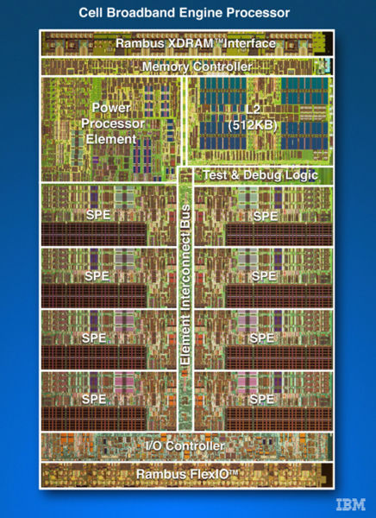
Figure 1 – IBM's Cell Broadband Engine Processor (Wikipedia 2007).

IBM’s “libspe” is the standard library that PPE programs use to access and manage SPEs. IBM’s CBE SDK is a complete CBE development environment that includes the IBM library and samples source code, IBM XL C/C++ Alpha Edition for CBE Processor, IBM Full-System Simulator for the CBE Processor, and an Eclipse-based Integrated Development Environment (IBM Cell Broadband Engine Software Development Kit 2005).

Terra Soft’s Yellow Dog Linux 5.0 distribution contains various developer tools. Also, it is the most complete thoroughly tested, professional Linux distribution for the Power architecture. However, because of its lack of maturity, the developer community is relatively small compared to more popular distribution alternatives [Paul 2007].
IBM’s SDK will be important for developing software to process the images of the turbine blades with erosion effects. The “libspe2” library was recently developed to allow for functional indirect use the PS3’s GPU. For software development, Vim seems to work the best as an IDE. Being that we are going to communicate with drivers, C/C++ is the direction we would be heading to accomplish the low-level tasks.

IBM’s Cell Processor

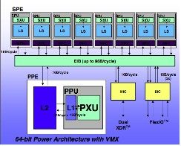
The cell processor is a non-homogenous coherent multiprocessor that is designed to work at high design frequencies and a low operating voltage with advanced power management. It also features a homogenous multi-core architectural system, better known as a Power Processor Element, for control tasks and Synergistic Processor Elements for intensive data processing (Valdes 2007).
Figure 2 – Cell Broadband Engine Architecture.

In Figure 2, the Synergistic Processor Element (SPE) consists of 8 Synergistic Processor Units (SPU) and a Synergistic Memory Flow Control (MFC). Essentially, we are looking at 8 cores processing data simultaneously while synchronized by the MFC and the Element Interconnect Bus (EIB) (Amarasingehe 2007). These SPUs are vector processors designed to simultaneously process a clusters of data at a high speed (Valdes 2007).
In order for the image capture data to be useful, it should be formatted into a suitable configuration so that the user can carry out proper analysis. Teams from previous semesters have been using JPEGs and converting them to gray-scale Bitmaps, which allows for image processing code to process raw image data.
It is necessary for the image format to be a lossless file type with a simple structure. Although the previous team has stated that the bitmap format made most sense for the project, our group will explore other possibilities.

Operating System

In using the PS3 Cell Broadband Engine chip, a compatible Operating System will have to be utilized. The PS3 has a PowerPC processor. Operating systems working only on x86 or x86-64 processors will not run on PS3’s cell (PS3 Linux FAQ Thread 2006). Therefore, only viable and sufficiently reliable options were considered and reviewed here. Their specific reactions on different configurations on PS3 were not observed. Among the candidates were various Free Linux distributions and FreeBSD which is an advanced UNIX based OS (Hertzfeld 2007).
As a conclusion of the research done on different operating systems, Yellow Dog Linux will be used because it is referenced as “the best ready package you can get, with some of IBM's Cell development tools preinstalled” for the Cell Broadband Engine (Yellow Dog 2007, AfterDawn.com 2007).

Networking

The PS3 will be receiving image data through the network port on-board. The network port is a Gigabit Ethernet, or 1000 Mb per second. The PS3 will be able to receive images from a network camera or a PC transferring data from a connected computer. For simplicity’s sake, a network camera is preferred for the project. A large majority of the cameras use FTP to transfer the images, which will make acquiring the images on the PS3 quite simple.
To compute the bandwidth that the team will be working with, the Axis 206 network camera specifications were used. The camera sends a 640 x 480 pixel image 30 times a second (CDW Corporation 2007). The picture is sent in JPEG, which converts to approximately 10:1 to 20:1 compression (Lane 2007). This means that the bandwidth the camera outputs is about 10-20 Mbs, which the Gigabit interface will be able to handle easily.
In order to enable the team to work on the project from outside the MDL, there will be a suite of remote access protocols installed onto the PS3. The team will be using SSH, VNC, and Samba. The team may need to find a work around VNC only supporting one user at a time, with a sort of VNC manager (Files Library 2005).

Image Capture

The camera the team will use is a Toshiba IK-53V, a small CCD camera with an approximate SVGA resolution, frame rates of 60 and 180 FPS at full and quarter resolution respectively, and shutter speeds as quick as 1/100,00 seconds. The fast shutter will limit blurring when photographing operating turbines, and the high frame rate at full resolution will ensure that, even if stationary, the camera will capture images of the moving blade.
The software side of the team’s solution will receive JPEG data from the camera and convert it into a more readily usable format in RAM. The decoding of the compressed data into a bitmap and the subsequent perspective correction for the borescope’s fisheye lens will occur in one step to conserve time and memory, and a simple high-pass filter will be enough to check each bitmap for acceptable image clarity. Depending on the program architecture the team decides on and our ability to use make the most of the PS3’s six available SPUs, useful image data will either be stored for analysis at the cost of immediate quantitative output or shifted between SPUs for quick processing at the potential cost of dropped input frames.

Image Analysis Algorithm

To effectively analyze the pictures taken by the camera, the images must first be fixed and prepared. Clarity, detail and sharpness of the images are all criteria to be considered before final analysis can be made. Three image analysis methods have been implemented in the past and each method has advantages and disadvantages.
The first method is subtraction: in this method, a subtraction function is used to subtract a base image from a second image to be processed. The advantages with this method are that it is relatively simple to implement and requires the least amount of processing power. However, this method is highly dependent on lighting and the alignment of the images (the images have to be perfectly aligned). It can be assumed that the turbine blades will be moving slow enough to capture steady images.
The second method is average distance; this method detects the longest straight line in the image and then calculates the average distance from the edge of the blade to a reference line. This method, unlike the subtraction method, doesn’t require perfect alignment. Instead, it will just shift the image, with respect to the position and the tilt of the image. Although consistency of the light is not as important the amount of light is. There needs to be sufficient lighting on the edge of the blade, and on the scribed line for this method to work properly.
The third method is edge size standard deviation; it verifies that the edge sizes have greater variance in more eroded buckets. This method is more robust and accurate compared with the other two suggested methods. However, the total number of steps needed to implement this method is greater than the other two methods.
After reviewing these methods, it was concluded that experimentation and testing will be the best way of deciding which image analysis approach is more effective and robust.

Image Processing

The commercial implementation of the IBM Cell Broadband Engine (CBEA) on the PlayStation 3 allows for much research to be done in the area of algorithmically possibilities at a relatively low cost. With a focus on image analysis and processing, previous teams used the many distinct elements of the PlayStation 3 to begin implementing simple imaging algorithms on the Fedora Core system. JPEG decompression into the BMP format was done using a free program called “djpeg” from the Independent Group (available at http://www.ijg.org). The decompression was done on the Synergistic Processor Units (SPU’s). Perl scripts were used to open JPEG images in specific directories automatically, split them into two distinct files, and then send them to two separate SPU’s. After the images were processed and a difference was determined, the information was stored locally on the PlayStation 3. A depiction of the image processing can be seen in Figure 3.

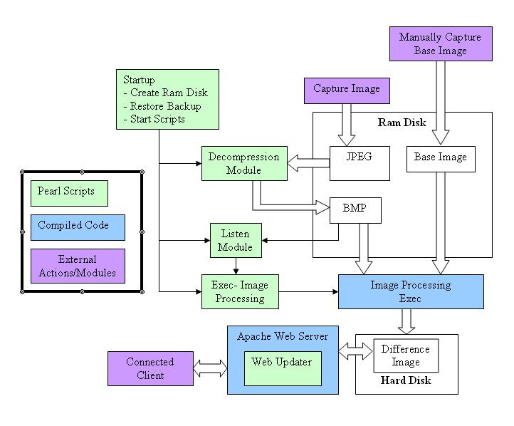
Figure 3 – Process Flow Diagram of Image Capture System for spring 2007 Team (Bara 2007, Cabral 2007).

As it stands, C programming is the main language that we can expect to utilize. The difference algorithms that were created seemed to have worked within reasonable time – more research needs to be completed on algorithm optimization. We are looking at possibly using the djpeg program & C routines or Image Magick, both compatible with the Yellow Dog OS (Bara 2007, Cabral 2007). They both provide us with potential imaging solutions that may help us in refining images and fully establishing accurate comparisons

Simulation Hardware

Currently, the simulation hardware consists of three main units: The first part consists of the housing for the mock turbine (this includes the blades and the motor). The second part consists of how the camera is mounted on the mock turbine, and how the lighting is setup. The last part consists of the electronics and control system for the motor and the image capture (either via a strobe light and camera of another method).

Figure 4 – Simulation Hardware
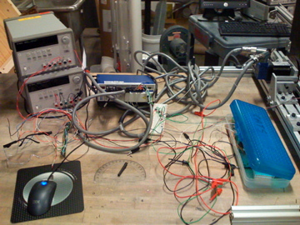
Figure 5 – Kollmorgen Servostar Controller

The photo above depicts the solution that was implemented last semester; which used a Kollmorgen Servostar Controller (MODEL NO. CR06250-000000 VERSION 3PH SERIAL NO. 00C-1099), some belt gears, potentiometers, resistors, a power supply, messy wires and an optical switch to control the simulation hardware. Although these components are capable of a great deal, they were implemented in a very sloppy fashion that could have lead to personal injury when operating the system.
The team is looking into using Labview (using a simple I/O board or a DAC card) to create a control system for the motor. This would provide a robust and safe way to test the other components of the project. For example, Labview can be used to monitor the motor’s speed and send signals to trigger the camera. Additionally, the lighting system can be interfaced with Labview to provide a high degree of flexibility.
Another method for controlling the simulation hardware would be to use an Arduino Microprocessor. The advantages of using an Arduino Microprocessor include: it is small and very robust, there are many input and output ports that are programmable and implementing would be relatively easy in comparison to a Labview System. Figure 6 shows a picture of the Arduino Microprocessor (Arduino 2007).
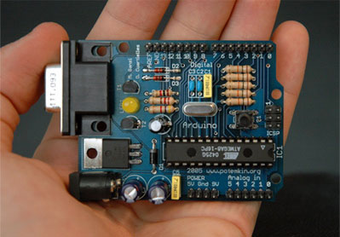
Figure 6 – Arduino Microprocessor (Arduino 2007)

Semester Objectives

The objectives the PS3 DSIVE team would like to fulfill involve integrating and expanding the work of previous groups. Working in conjunction with the fall 2007 GE Erosion team, we wish to create a working system that satisfies the expectations of RPI, GE, and IBM.
The objectives the team wishes to achieve are largely image processing issues, especially those involving developing systems for the PS3. There is an assumption that we are being provided a quality image from the borescope. This digital image is taken from the network onto the PS3, distributed to processors, analyzed, and the output is sent to a log for viewing.

Install Yellow Dog Linux on PS3
- Objective: Install an operating system on the PS3
- In Scope: Installing various SDKs for development
- Out of Scope: Modifying the kernel for modification

Establish Network Connectivity and Access
- Objective: Make the PS3 accessible from the network
- In Scope: Configuring a static IP address for the PS3
- In Scope: Setting up VNC, SSH, and Samba for remote access
- In Scope: Establish connectivity to the PC or network camera
- Out of Scope: Managing network resources between the camera and PS3

Transferring Image to the PPE for processing
- Objective: Transfer the data from the network interface to the PS3 processor
- In Scope: Move the data from the FTP stream to the PPE
- In Scope: Converting the image to a bitmap format for analysis
- Out of Scope: Transferring the image data directly from the network through sockets

Develop Parallel Processing Usage
- Objective: Utilize the parallel computing power of the CBEA
- In Scope: Using scripts to send data to multiple processors
- In Scope: Install software that optimizes code for multiple processors
- Out of Scope: Developing an architecture that converts code into a parallel computing system

Implement Image Optimization
- Objective: Optimize bitmap images so that they may be better analyzed
- In Scope: Implementing sharpening algorithms
- In Scope: Implementing rotating and sizing algorithms
- Out of Scope: Developing algorithms for optimization
- Out of Scope: Implementing complex image processing algorithm conversions

Implement Image Differentiation
- Objective: Compare two or more images analytically
- In Scope: Implementing multiple comparison algorithms
- In Scope: Creating a scale for determining the amount of difference
- Out of Scope: Developing new differentiation techniques
- Out of Scope: Creating custom digital imaging processing software for the PS3

Output Results to PS3
- Objective: Send the results of the differentiation to an output log
- In Scope: Establishing a directory and output system for results
- In Scope: Sending the output to a simple GUI output
- In Scope: Transferring the output to a system log on the network
- Out of Scope: Developing a GUI for output

Challenges

Linux on the PS3 cannot access the full feature set used by commercial games, as Sony’s firmware implements a hypervisor (super-supervisor) to restrict access to the Reality Synthesizer (RSX). As such, all image processing will be done purely in software. The Cell processor is vector-based, meaning multiple operations can be performed per cycle in each SPU, and this detail works nicely with the matrix-heavy nature of the team’s goals.
Existing work from previous PS3 programming projects at RPI are coded largely in MATLAB. MATLAB’s licensing is very expensive, costing several times more than the combined cost of hardware for this project. Similar programs exist for Linux, but the ones that are free of cost are not 100% compatible with MATLAB code. Any high-level functions specific to MATLAB will need to be replaced or duplicated if the team chooses to avoid the need for licensing fees.
The PS3’s 2 gigabytes of RAM needs to be operated on by as many as six SPUs, so finding the megabyte or so of contiguous memory needed for each frame 60 times a second could become problematic. If the images cannot be processed quickly enough, potentially useful frames will be dropped as they come in over the network thus, slowing down the collection and analysis of erosion data.
The IK-53V does not connect directly to the PS3. Currently, it requires a PC to receive and retransmit image data over the network. In the future, either the camera will need to be replaced or some inexpensive way of connecting the camera to the PS3 must be devised.
The turbine blades will not be precisely lined up or consistently oriented in-frame. As there is no human operator present to mark the rotation of the blades, except possibly for one calibration image, the rotation and translation operations to correct for the movement of the blades will need to be heavily automated.
Once oriented predictably, the images of the blades must be compared in a meaningful way to find an average blade and compare it with the average blade images from previous sessions with the turbine. The differences between old and new images must be reduced to an easily stored format and given a meaningful quantitative score based on the visible erosion over time.
Contracts with IBM prevent the team from mixing any code written specifically for this project with GPL or BSD-licensed code (“open source”). This means that all software on the PS3 Linux platform must be treated as closed-source, removing potential avenues for optimization and forcing ignorance of potential sources of algorithms for complex operations.

Professional and Societal Considerations

The Cell processor that is used in the PS3 is a remarkable technological breakthrough. This technology can be used to solve many complex problems in a short amount of time. With the rise of any new powerful technology, there are always professional and societal implications that will impact the public. This technology could help solve a great deal of today’s processor intensive problems. However, it could also be used to develop applications and hardware that invade the public’s privacy and potentially be used against them (similar to spyware on laptops).
Currently, the largest issues deal with privacy and biometrics. For example, a major field that the PS3’s processor is used in is video surveillance and facial recognition. Presently, there exist technologies that can be used to identify a person’s face from a photo database (such as the driver’s license photo database). These programs take time to operate and process the images. The PS3 Cell processor and PS3 Hardware could be used to automate the process of image capture (similar to what the team is proposing) and facial recognition. The Cell’s processor would streamline the process and there would be a tremendous increase in performance and with respect to both the accuracy through more complex matching algorithms and number of images processed. This increase lowers the cost and increases the benefits of these systems (Cabral, 2007).
In addition, there are video surveillance software packages that use smart surveillance in an attempt to decrease traffic violations, economic loss, public threats and other unsafe activities. These technologies have helped to decrease crime rates and help increase the public’s safety. The ethical question that comes into play in this case frequently deals with the issues of personal privacy versus public safety. The Supreme Court states that a search occurs when government action invades a person's reasonable expectation of privacy (Cabral 2007).
The Cell processor would take these current professional and societal impacts a step further. For example, when entering a mall a person might be identified and photographed with a camera. This image would then be sent to a facial recognition software package that compares the image with a photo database. Due to the PS3’s incredible processor, multiple people could be scanned at checkpoints and tested all at once. Also, the software and hardware in this project could be portable and very easily placed in private locations. This would be a big invasion of privacy and would definitely cause public controversy. In addition, if this system were to operate over a network, then the system would have the potential to leak information. This leak would be very dangerous in terms of legal implications and public safety.
Systems will ultimately require human regulation and involvement. Potential matches must be verified and followed up with the human eye to confirm identity. As the system becomes more powerful, the potential for abuse also increases (Cabral 2007).
The Cell processor could be used in many systems that would be able to create similar devices as the one described above. This is why the creators of the device have to ensure that clients who use the device follow ethical and social regulations. A written contract should also be signed so that the team responsible for the system that used the Cell processor is not responsible for the use of the device in inappropriate ways. As the creators of the system, we have no responsibility or tie with how the software/hardware is used by our clients. The understanding is that the system is to be used as described in the project description received by the team at the beginning of the project. However, this does not mean that we will ignore the potential side effects of our end product. This means we have to create a level of public understanding about the technologies abilities and potential uses (Cabral 2007).
Finally, since GE and IBM are sponsors, this project will meet the professional and societal standards which were provided by both companies. The team has signed all the appropriate legal papers and has understood the privacy contracts that GE and IBM have provided.

Project Plan

Summary of Methodology

Based on the client requirements presented, the team will investigate and define objectives to identify the problems associated with the current environment that are to be resolved. In order to reach the team objectives, the first step is to analyze the current available systems. The project’s development and implementation environments were carefully selected based on the technically feasible options available. The physical design of the project includes multi-layered preparation that involves learning the rules of the implementation environment, reviewing the precise requirements for logical to physical mapping and planning the approach. Once completing the specification of tasks, tests to determine the strength of the data process design will be carried out repeatedly to encourage extended development. The objective of this phase is to determine the physical data and process design using the components and features of the chosen physical environment and incorporating installation standards.
As part of the research involved, proper documentation should be done such that it is not contained solely within a certain individual. Therefore, all research and design processes are to be posted in the corresponding section of the ECSE Design forums (https://forum.ecse.rpi.edu/). Major research areas will include PlayStation 3 (PS3), image processing, IBM’s Cell SDK, Yellow Dog Linux OS, and Optimization Algorithms for related topics.
The overall layout of the system design must be pieced out into several components before making any changes or additions to the hardware. However, we should be aware of certain constraints that will be based on the design and the design’s practicability. Knowing that the project will be heavily based on the software design, the design will be utilizing the Unified Modeling Language (UML) as much as possible to accommodate better understanding and referencing. This pertains to specific program functions and algorithms. The entire system will be documented using proper graphical notations to create an abstract model of the system so that no twists are present well before delving into the development phase. It is also important note that most detailed diagrams and planning will go into the algorithm designs simply because of its complexity. As a result, there must be detailed design documentation on the process and reasons behind the choices that are made.
Reports are divided into sections, with each group or team member working on a specific area. The team will also meet to review parts that members have written, and to help with sections that require input from the entire team. After the individual sections are written, one or two team members designated, as editors will put the parts together and edit the report for consistency and grammar. At each meeting, detailed minutes are recorded and posted in the forums for future references.
Previous team’s setup on the PS3 included the Fedora 5 Linux. The team has decided that the best option is to install Yellow Dog Linux on the PS3. After carefully examining the hardware, the team discovered that the simulation hardware that was used for image capturing was not properly intact and labeled. Therefore, the next design iteration will incorporate the usage of Labview, a Data Acquisition Card and basic circuitry to control the simulation hardware.
The source code for the project will be managed through version control. Other updates will be made through the forum, keeping team members up to date on status of various sections.
The following is a list of the Project Team and Team Skill Sets:

- Paul Ireifej
  - Computer and Systems Engineer & Computer Science
  - Hardware/Software Communication
  - Database Design
  - GUI Programming
- Justin Law
  - Computer and Systems Engineer
  - Control Systems concentration
  - Image Processing and documentation writing
  - C/C++
- Carlos Lazo
  - Computer and Systems Engineer & Computer Science
  - Automatic control and robotics concentration
  - C/C++, Java, Python, Scheme, VB/VBA, SQL
  - Experience using Linux
- Nick Matthews
  - Computer and Systems Engineer & Computer Science
  - Networking Concentration
  - Cisco Certified Networking Associate (CCNA)
  - Cisco Certified Networking Professional (CCNP)
  - C/C++
- Shahab Rastegar
  - Electrical Engineer
  - Matlab Image Processing
  - C/C++
- Thomas Smith
  - Computer and Systems Engineer
- Syed Reza Ali
  - Mechanical and Electrical Engineer
  - Adobe (Photoshop, Illustrator, Premiere, Flash, Dreamweaver)
  - Arduino Programming and Processing Programming
  - Circuit Design (digital, analog) & Embedded Control
  - Autodesk Maya, Solidworks, Cinema 4D
- Mahmutcan Tarzi
  - Computer and Systems Engineer
  - Automatic Control and Robotics concentration

Work Breakdown Structure and Estimations

Preliminary assignments are based on individual interests:
Networking & Operating Systems Team
- Paul Ireifej
- Mahmutcan Tarzi
Image Processing Team
- Justin Law
- Carlos Lazo
- Shahab Rastegar
Interface & API Team
- Nicholas Matthews
- Syed Reza Ali
- Thomas Smith

Schedule

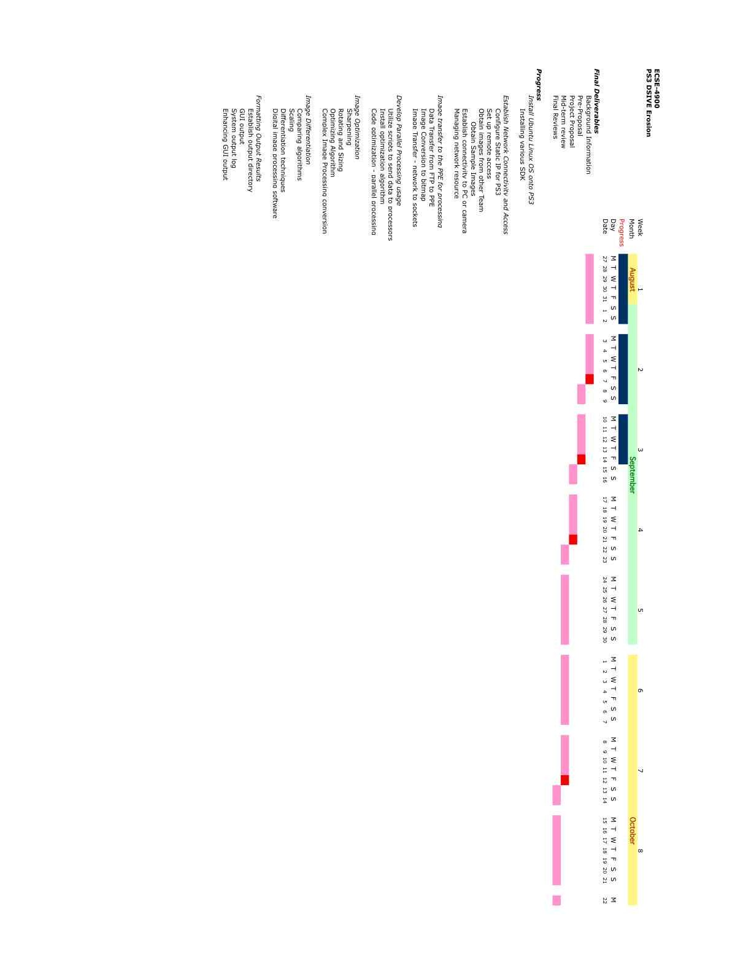

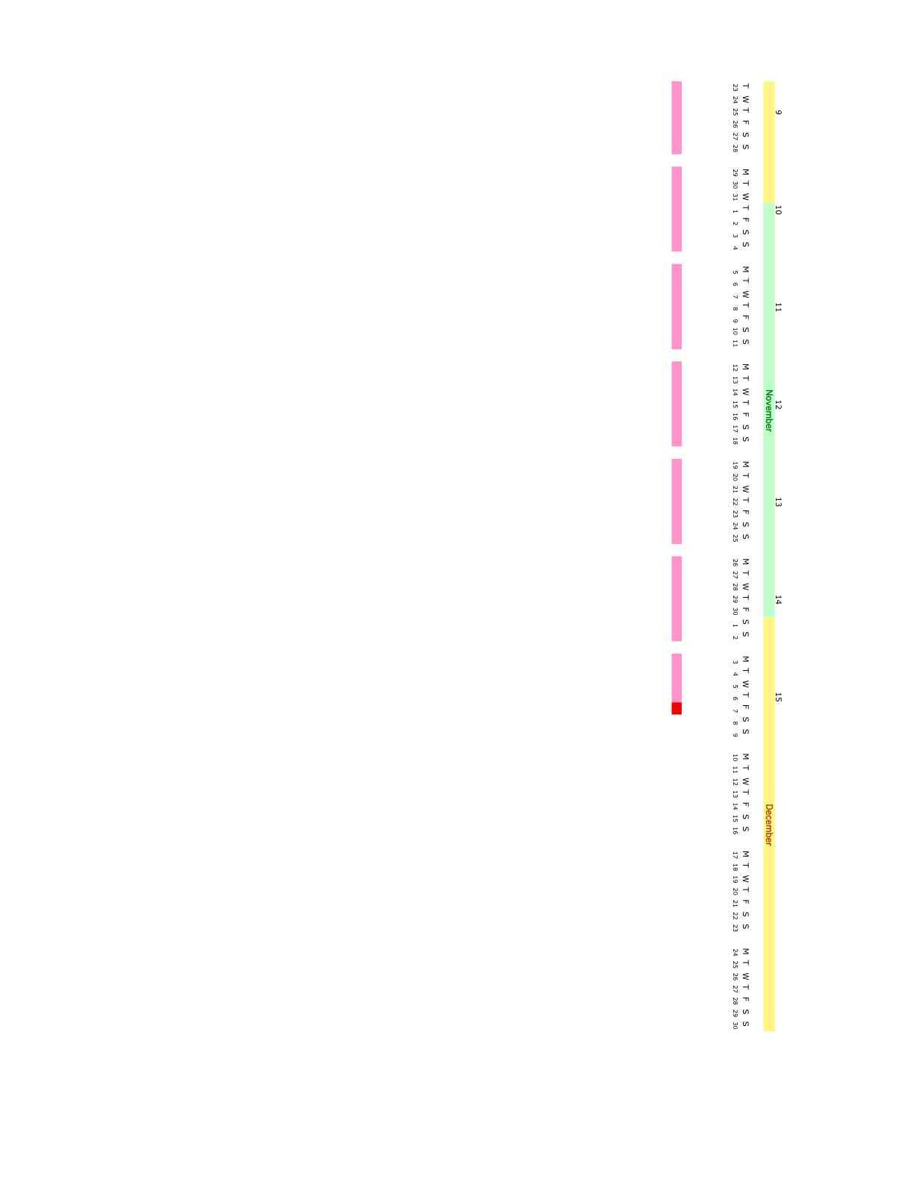

Figure 7 – Gantt chart

Budget

Item | Estimated Cost (US$)
PlayStation 3 | 500.00
Mercury Computer Systems MultiCore Plus SDK | 400.00
Data Acquisition Card – LabJack U3 | 100.00
Circuitry – Potentiometers, resistors, wire and optical sensors | 50.00
Toshiba Camera - IK-53V | 480.00
Table 3 - Budget

Based on the table above, the team’s preliminary budget adds to a grand total of $1,530.00.

Deliverables

- Installing Linux on PlayStation 3 and getting core functionality, printing “Hello, World” on the screen and to a log.
- Receiving an image through the network, optimizing it, and analyzing it.
- Building a data log that will provide insight into the erosion status of the blades.
- A combination of a CPU, operating system, SDK, image processing software, programming language, and algorithms that work effectively with each other.
- Final report
- A mid-term review and a documented process of our design, so that our work can be understood and expanded upon.
- A PS3 that will accept an image of a predetermined size and quality and output a data log with erosion analysis.

References

AfterDawn.com, Forums, Internet. (2007) Available: http://forums.afterdawn.com/, September 2007.

Amarasingehe, S., & Rabbah, R., Multicore Programming Primer: Lectures, Internet. (2007) Available: http://cag.csail.mit.edu/ps3/lectures.shtml, September 2007.

Arduino, What is Arduino?, Internet. (2007) Available: http://www.arduino.cc/, September 2007.

Bara, T., Carcich, B., Gibb J., Huang R., Lang A., Malarik, D., & Sylvestre B. (2007). Final Report for Medical Imaging with PS3 and Cell Processor, 2 – 69.

Cabral, R., Chu, J., Hall, I., Mullin, J., Nakagawa, P., Quinn, R., & Smith, F. ( 2007). Final Report for PS3 DSIVE: Distributed Shared Immersive Visualization Environment, 2 – 74.

Carcich, Benjamin. (2007). Background Information Regarding Cell SDK Programming.

CDW Corporation, AXIS 206 Network Camera, Internet. (2007) Available: http://www.cdw.com/shop/products/specs.aspx?EDC=697029&cm_sp=Product-_-Specs-_-Main+Tab, September 2007.

Changes in libspe: How lipspe2 affects Cell Broadband Engine programming, Internet. (2007) Available: http://www.ibm.com/developerworks/linux/library/pa-libspe2/index.html?ca=drs-m, September 2007.

Files Library, Free Download VNC Manager, Internet. (2005) Available: http://www.files-library.com/files/VNC-Manager.html, September 2007.

FreeBSD: The Power to Serve, FreeBSD / ppc Project, Internet. (2007) Available: http://www.freebsd.org/platforms/ppc.html, September 2007.

Gentoo Linux, About Gentoo, Internet. (2006) Available: http://www.gentoo.org/main/en/about.xml, September 2007.

Helpero, UBUNTU vs. SUSE vs. FEDORA, Internet. (2006) Available: http://news.helpero.com/article/UBUNTU-vs-SUSE-vs-FEDORA_20.html, September 2007.

Hertzfeld, Andy, “Programmers at Work”, Internet. (2002) Available: http://pages.prodigy.net/wheel3/wip/os_wars_rage_on.txt, September 2007.

IBM Cell Broadband Engine Software Development Kit, Internet. (2005) Available: http://www.alphaworks.ibm.com/tech/cellsw, September 2007.

Lane, Tom, JPEG Image Compression FAQ, Internet. (1999) Available: http://www.faqs.org/faqs/jpeg-faq/part1/, September 2007.

LinuxDevices.com, SDK aims Playstation 3 clusters at HPC apps, Internet. (2007) Available: http://www.linuxdevices.com/news/NS4555177850.html, September 2007.

Mullin, James (2007). Individual Deliverables #2.

Nakagawa, Patrick. (2007). PS3 DSIVE.

Oregon State University, Open Source Lab, Internet. (2007) Available: http://gentoo.osuosl.org/experimental/ppc64/livecd/, September 2007.

Paul, Ryan. Yellow Dog Linux on the PlayStation 3, Internet. (2006) Available: http://arstechnica.com/articles/columns/linux/linux-20061018.ars/2, September 2007.

PS3 Linux FAQ Thread, QJ.NET Forums, Internet. (2006) Available: http://forums.qj.net/f-ps3-linux-283/t-ps3-linux-faq-thread-78750.html, September 2007.

Psubuntu.com, Why PSUbuntu?, Internet. (2007) Available: http://psubuntu.com/about, September 2007.

Rousseau, Stacy, Steam Turbines: A look into how a steam turbine functions, Internet. (2001). Available: http://www.nd.edu/~techrev/Archive/Fall2001/a5.html, September 2007.
Silverman, Dwight, Ask TechBlog: Ubuntu or Vista?, Internet. (2007) Available: http://blogs.chron.com/techblog/archives/2007/01/ask_techblog_ubuntu_or_vista.html, September 2007.

Valdes, Robert, How PlayStation 3 Works, Internet. (2007) Available: http://electronics.howstuffworks.com/playstation-three5.htm, September 2007.

Yellow Dog, Linux Community Board, Internet. (2007) Available: http://www.yellowdog-board.com/, September 2007.

Wikipedia, Cell (microprocessor), Internet. (2007) Available: http://en.wikipedia.org/wiki/Cell_microprocessor, September 2007.
Wikipedia, Steam turbine, Internet. (2007) Available: http://en.wikipedia.org/wiki/Steam_turbine, September 2007.

Appendix A: Test Plan

Testing is to be conducted in order to ensure that all team goals have been met and also to validate that our design meets customer requirements. To do so, the team must create a prototype. The prototype shall be then used to simulate real world conditions. These simulations will show vulnerabilities and errors that must be addressed.
Two testing environments shall be set for testing; one will be the PS3 with Yellow Dog installed and the other will be emulation software for the PS3 which will be run on student laptops. Below please find a list of areas which will require testing and analysis:
Install Yellow Dog Linux on PS3 –
After the installation of Yellow Dog Linux, there must be tests conducted to gage the stability and robustness of the system. These tests may include stress testing and verification that services required for the project are working (e.g. SDK).
Establish Network Connectivity and Access –
Verify that the PS3 can be remotely accessed and files are transferred over the network with no corruption. SSH, VNC and SAMBA must all be tested. Testing must also be done to ensure that pictures can successfully be transferred from the PC connected to the camera to the PS3.
Transferring Image to the PPE for processing –
The bridge between the FTP stream and the Power Processing Element (PPE) must be tested.
Develop Parallel Processing Usage - the team must conduct testing In order to gage the effectiveness of the Parallel Processing. Same image shall be processed with and without Parallel Processing and the time difference will be measured.
Image Optimization and Differentiation – this section of the project will be the most code intensive. The algorithms implemented must one by one be tested for both accuracy and efficiency.
Output Results to PS3- the final step in our testing process will be to test the output. The output will be in form of a log; this log must be tested to ensure that it is consistent with the results of analysis algorithm. A simple GUI will also be used to ease the use of the software. Command shall be issued using this GUI. The Functionality of this GUI must be tested.

Appendix B: Personnel

Appendix C: Yellow Dog Installation

The following steps are taken from http://www.terrasoftsolutions.com/support/installation/ydl5.0.2_ps3_guide.pdf but are summarized.
- Update Game O/S Software. This is done through [Select Settings] > [System Update] > [Update via Internet].
- Format the PS3: [Settings] > [System Settings] > [Format Utility] > [Format Hard Disk] > [Yes] > [Yes],
- Select the “Custom” partition setting for the hard disk.
- Select “Allot 10GB to the PS3 System.”
- Select “Quick Format.” Select “Yes” when prompted. The PS3 will now format its internal drive.
- When the process ends, reboot the PS3 (or select “EXIT”).
- Make sure your YDL CD contains the directory “/ps3/otheros” and contains the file “otheros.bld.”
- Insert the YDL CD into the PS3.
- Select [Settings] > [System Settings] > [Install other OS].
- When prompted to boot Other OS, select “Yes.”
- To return to the GameOS at the kboot prompt, enter the command “boot-game-os”, or hold the power button down for about 5 seconds (and resets your PS3 to factory default).
- You can either allow the installer to create the partitions for you by selecting “Automatic Partitioning,” or choose to do it manually.
- If you choose “Automatic Partitioning”, select the “Remove all Linux partitions” option.
- If you choose to partition manually, create “swap” with at least 512 MB, “home” with at least 1 GB and “/” with at least 10 GB.
- The Dependency Check will take 3-4 minutes.
- The installation process will begin, and takes roughly one hour.
- When it is finished, select “Reboot” to restart the PS3.
- Finally, follow the “Firstboot” configuration wizard.

